SIMATS ENGINEERING

ASSESSMENT TOOL 3

COURSE NAME: COMPUTER NETWORKS COURSE CODE: CSA0704

COURSE OUTCOME COVERED
CO2: Configure IP addressing schemes, subnetting, and basic routing techniques using simulation tool, for efficient network design and topology. (BL3)
Assessment Tool Weightage: 30% Software:Cisco Packet Tracer,Wireshark

QUESTIONS: 5 Total Marks:50

Annexure A

Debugging & Optimisation Task

Code of Conduct:

I Monika M / 192521435 (Name / Reg No) certify that this submission is my original work and that I have adhered to the guidelines specified for this assessment.
I understand that any violation of academic integrity rules will result in disciplinary action.

Signature of the student:

Monika M

Annexure A

Debugging & Optimisation Task

- An organization has allocated the network 192.168.1.0/24 into several departments using the subnet masks /26, /27, and /28. Some departments report insufficient IP addresses, while others have a large number of unused addresses.

Task

Analyze and optimize the subnet allocation by:

  - Identifying the network address, broadcast address, and host range for each subnet.
  - Calculating the number of usable and unused IP addresses.
  - Identifying inefficient subnet allocations.
  - Debugging the addressing plan by locating subnet allocation mistakes.
  - Recommending an optimized subnetting scheme using VLSM to improve address utilization while supporting current departmental requirements.

RUBRICS FOR CALCULATION

Criteria | Weightage | Level 4  (Exemplary) | Level 3 (Proficient  ) | Level 2  (Developing) | Level 1  (Beginning)
Problem Identification | 20% | Accurately identifies all errors and  root causes  with clear understandin g | Identifies most errors with minor gaps | Identifies some errors  but misses key issues | Unable to identify errors correctly
Debugging | 25% | Applies systematic debugging techniques effectively to  resolve issues | Uses appropriate debugging methods with minor  errors | Limited debugging approach; requires guidance | Unable to  debug or resolve issues
Optimization | 20% | Optimizes code by significantly improving time complexity using efficient algorithms | Improves time complexity with minor gaps in efficiency | Limited improvement in time  complexity | No improvement; inefficient approach retained
Analysis | 20% | Demonstrates strong logical reasoning and clear justification  of solutions | Shows reasonable analysis with some justificatio  n | Limited analysis; weak reasoning | No analytical reasoning demonstrated
Code Quality | 15% | Produces clean, well-structured code with proper comments and documentatio n | Code is mostly clear with minor documentat ion gaps | Code lacks structure and proper documentatio n | Poorly written code with no documentatio n

CORRECT OUTPUT:

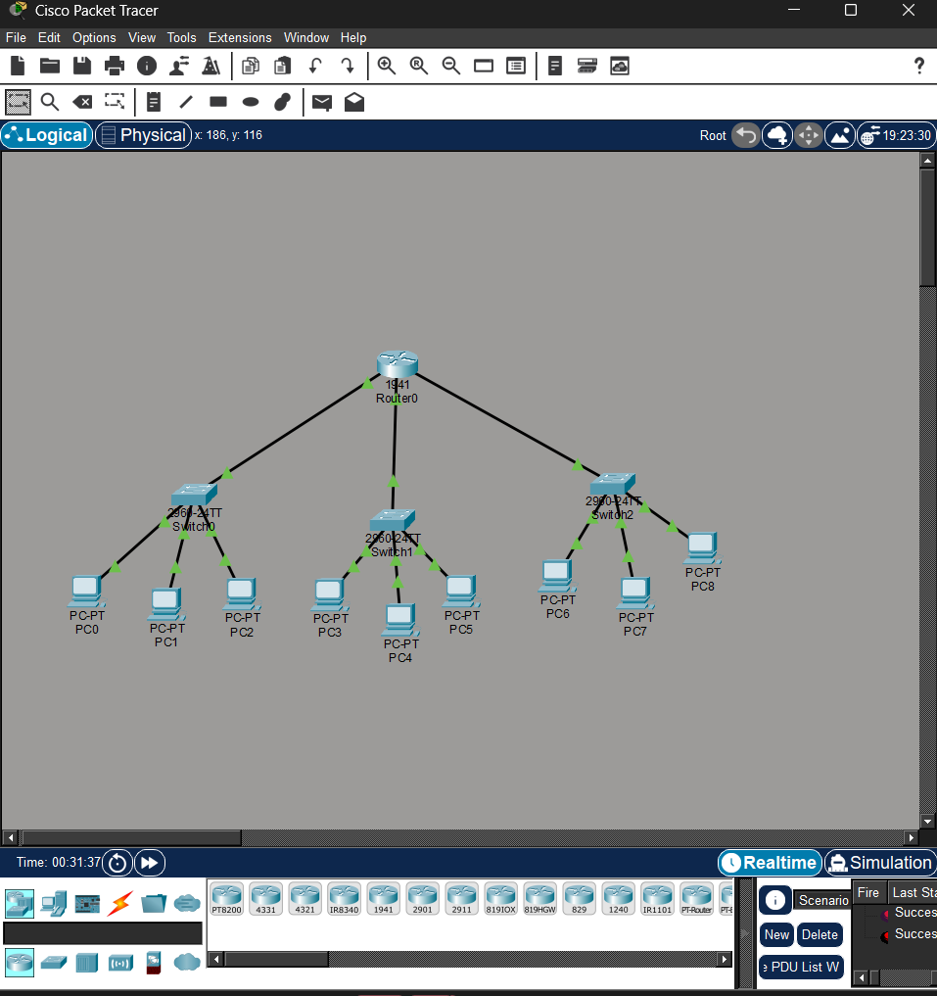

ENTERING THE WORNG IP ADDRESS

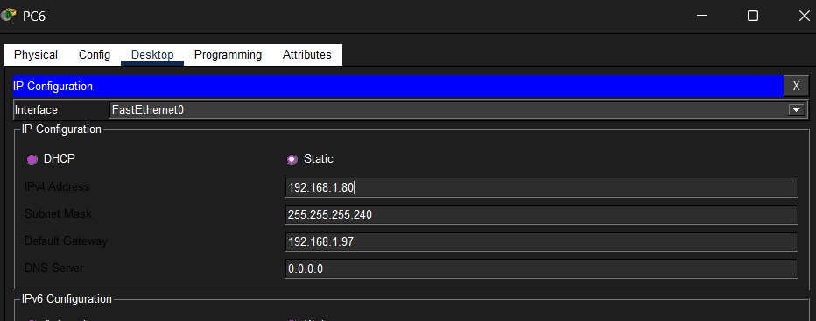

DEBUGGING AND OPTIMISATION

